13.87:

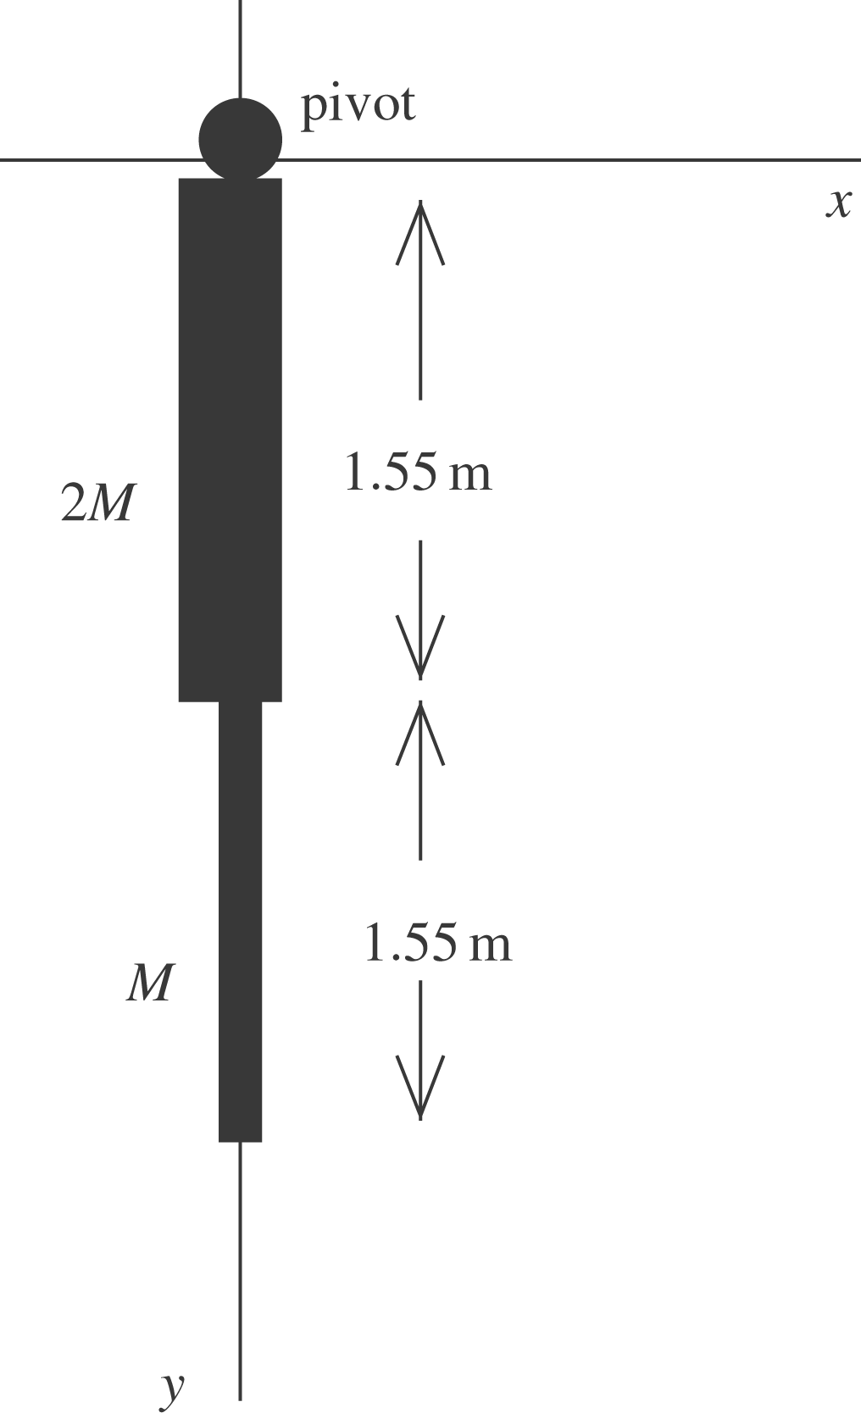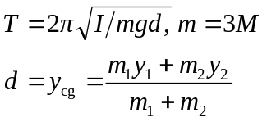

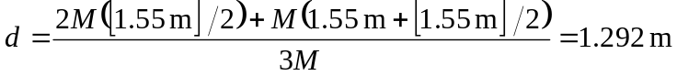

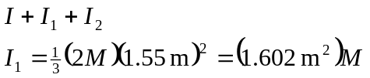

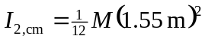

The parallel-axis theorem (Eq. 9.19) gives
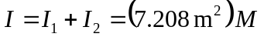
Then 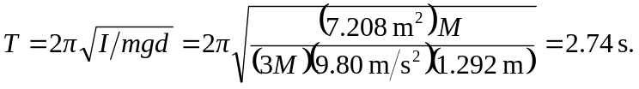
This is smaller than 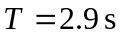found in Example 13.10.

